AI Chatbots for Answering FAQs and Delivering Services in Smart Campus Governance
Shayan Rizwan Yazdanie
Department of Computer Engineering
Ghulam Ishaq Khan Institute Of Engineering Sciences and Technology (GIKI)

Abstract—The integration of Artificial Intelligence (AI) chat- bots within smart campus ecosystems represents a significant advancement in administrative and educational service delivery. These systems, leveraging Natural Language Processing (NLP), Machine Learning (ML), and Retrieval-Augmented Generation (RAG), move beyond simple FAQ automation to offer personal- ized, context-aware support for students and staff. This paper presents a comprehensive review of state-of-the-art implementa- tions at leading global universities, analyzing their technological foundations, operational scope, and measurable impacts. Building on the strengths and limitations of existing models—such as Geor- gia State University’s “Pounce” and the University of Michigan- Flint’s “Maizey”—we propose CampusConcierge, a novel hybrid architecture. This solution integrates a RAG-based conversational AI with real-time Internet of Things (IoT) sensor data and campus information systems through a microservices framework. Key innovations include a federated learning component for privacy-preserving model updates and a multimodal input layer. The proposed system is designed to address critical gaps in context retention, real-time data fusion, and scalability, aiming to reduce administrative workload by 30-50% while significantly enhancing user satisfaction and operational efficiency in smart campus governance.
Index Terms—Artificial Intelligence, Chatbot, Smart Campus, Smart Governance, Retrieval-Augmented Generation (RAG), Natural Language Processing, Internet of Things, Federated Learning
Manuscript received December 19, 2025. This work was advised in part by the Pro Rector Academics of GIKI, Prof. Dr. S. M. Hasan Zaidi.
Shayan Rizwan (Author) is a student at GIKI, currently in Sophomore year, pursuing Computer Engineering (CE). (e-mail: u2024585@giki.edu.pk).

- Introduction
The evolution of “smart campuses” extends beyond digi- tal infrastructure to encompass intelligent governance, where data-driven tools optimize resource management and user experience. In this paradigm, AI-powered chatbots have tran- sitioned from novel experiments to essential service platforms, handling inquiries ranging from administrative procedures to academic guidance. Their ability to provide 24/7, consistent, and scalable support addresses persistent challenges in student services and administrative efficiency. This paper explores the role of advanced AI chatbots as a cornerstone of smart campus governance. Following a review of exemplary global implementations, we conduct a comparative analysis to distill best practices and identify common technological and opera- tional hurdles. Subsequently, we contribute a detailed technical proposal for an integrated chatbot architecture designed to
overcome these limitations, thereby offering a blueprint for next-generation, context-aware campus assistants.
- Literature Review: State-of-the-Art
Implementations
AI chatbots in higher education have evolved from rigid, rule-based systems to adaptive, learning-driven interfaces. Leading institutions now deploy solutions that integrate deeply with campus digital ecosystems, offering services far surpass- ing basic information retrieval.
Georgia State University’s “Pounce” stands as a pioneer- ing example, operational since 2016. This system utilizes AI- enhanced text messaging (SMS) to deliver targeted “nudges” related to financial aid deadlines, course registration, and even quiz reminders in specific courses like Political Science. Its demonstrated success in improving student retention and grades underscores the impact of proactive, personalized com- munication [1]. The primary technological focus is on targeted messaging agents integrated with the Learning Management System (LMS).
The University of Michigan-Flint’s “Maizey” represents a more recent advancement employing a Retrieval-Augmented Generation (RAG) architecture. By integrating with the Canvas LMS and querying a custom, vetted knowledge database, Maizey provides accurate answers to over 3,500 distinct query instances spanning tutoring, campus transportation, and dining hall hours [2]. The RAG framework is crucial for mitigating “hallucination”—a common flaw in generative AI where mod- els produce plausible but incorrect information—by grounding responses in authoritative source data.
Wittenborg University’s AI Assistant, developed in part- nership with AnyforSoft, illustrates a cost-effective, scalable approach. It connects directly to the university’s website and Customer Relationship Management (CRM) systems to answer program-specific queries for prospective and current students [3]. Its strength lies in streamlined integration for rapid deployment, though its scope is primarily limited to static information retrieval.
The BRAC University Mentor Bot incorporates a struc- tured data ingestion pipeline, processing information from CSV files and webpages. Using NLP techniques, it provides guidance on admissions and academic pathways [4]. Future roadmaps for this system include reinforcement learning for handling complex, multi-turn dialogues and expanding multi- lingual support, pointing toward more adaptive future systems.

Collectively, these case studies confirm a global trend: effectively implemented campus chatbots can reduce routine staff workload by 40-60% while providing unwavering 24/7 accessibility [5]. The progression is clearly toward systems that are more integrated, context-aware, and built on sophisti- cated AI paradigms like RAG.
- Comparative Analysis
A side-by-side evaluation of the reviewed solutions reveals distinct strategic and technological choices, as summarized in Table I (Page # 3).
The analysis identifies two critical gaps common to most existing systems: (1) limited ability to incorporate dynamic, real-time data (e.g., room occupancy, facility status) from IoT sensor networks, and (2) challenges in maintaining large, up- to-date knowledge bases without significant manual oversight. Our proposed solution directly targets these gaps.
- Proposed Solution: The CampusConcierge
Architecture
Informed by the reviewed systems, we propose Campus- Concierge, a hybrid AI chatbot architecture designed for deep integration within the smart campus ecosystem. The solution synthesizes the reliable knowledge retrieval of RAG (inspired by Maizey) with the capacity to ingest and reason about real- time data streams.
- System Architecture & Technical Details
The architecture, depicted in Fig. 1, is built on a mi- croservices paradigm to ensure modularity, scalability, and independent deployment of components.
  - Multimodal Input Layer: Accepts user queries via text or voice. A speech-to-text module (e.g., OpenAI’s Whisper API) converts audio to text for unified processing.
  - NLP Preprocessing & Intent Engine: Incoming text is tokenized and analyzed. A fine-tuned BERT-based classifier determines user intent (e.g., “FAQ Retrieval,” “IoT Query,” “Service Request”). This step routes the query to the appro- priate downstream handler.
  - Dynamic Knowledge Retrieval Core: This is the system’s innovation center. For standard FAQs, it uses a RAG pipeline: queries are embedded and matched against a vector database (e.g., FAISS or Pinecone) populated with campus knowledge (handbooks, policy docs, course catalogs). Crucially, a parallel “IoT Gateway” microservice can query real-time APIs for live data (e.g., library seat occupancy from sensors, shuttle bus GPS locations, energy usage in buildings). Retrieved documents and real-time data snippets are synthesized into a unified context.
  - LLM Generation & Orchestration: A mid-sized, instruction-tuned LLM (e.g., Llama 3 or Claude 3 Haiku) generates a natural language response based on the provided context. A confidence score is assigned. If below a threshold (e.g., 0.8), the query is escalated to a human agent via a ticketing system interface, ensuring reliability.
  - Federated Learning Module: To update the NLP/LLM models without compromising user privacy, a federated learn- ing client runs on edge devices (e.g., campus servers). Model updates learned from local, anonymized interactions are ag- gregated periodically to improve the global model, adhering to strict data governance standards like GDPR [6].
Deployment & Integration: The system is containerized using Docker and orchestrated with Kubernetes, deployable on cloud (AWS/GCP) or on-premises infrastructure. Integration with Student Information Systems (SIS) and LMS is achieved via secure RESTful APIs and message brokers (e.g., Apache Kafka for IoT data streams). Target response latency is under 2 seconds for 95% of queries.
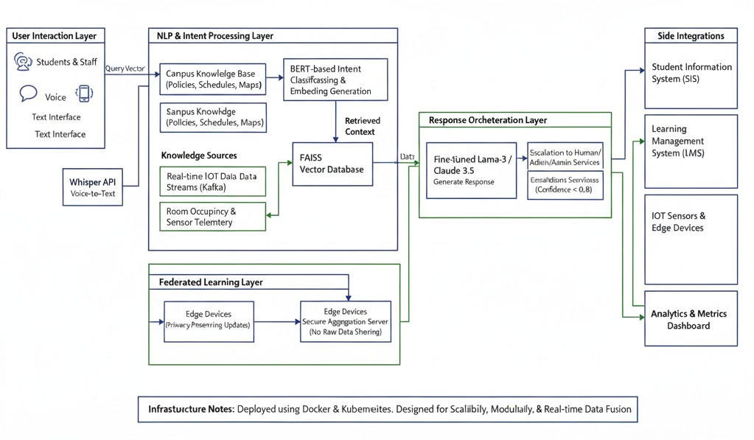

Fig. 1. High-level architecture of the proposed CampusConcierge system, showing the integration of RAG, IoT data streams, and federated learning within a microservices framework.

- Expected Outcomes & Advantages
This architecture directly addresses the limitations noted in Section III. By fusing static knowledge with real-time IoT data, it enables novel queries like “find me a quiet study room with open power outlets now.” The federated learning approach ensures the system continuously improves while preserving data privacy. We anticipate this design can reduce the volume of routine administrative queries handled by staff by 30-50%, while providing a more satisfying, context-aware user experience.
- Conclusion and Future Directions
This paper has reviewed the evolution of AI chatbots as critical components of smart campus governance, highlighting transformative implementations from Georgia State University to the University of Michigan-Flint. The comparative analysis reveals a maturation path from simple notification systems to sophisticated, knowledge-grounded conversational agents. Our proposed CampusConcierge architecture contributes a concrete technical blueprint that advances the state-of-the-art by integrating real-time IoT data with a RAG-based knowl- edge system and employing federated learning for ethical AI development.
Future work will focus on several key areas: establishing robust ethical AI governance frameworks for auditability and bias mitigation, implementing voice biometrics for secure

TABLE I
Comparative Analysis of AI Chatbot Implementations in Higher Education

Solution (Univer- sity)
Core Technology Primary Service Scope Key Strengths & Limita-
tions

Pounce (Georgia State)

Maizey (U. Michigan-Flint)

Wittenborg AI As- sistant
AI Messaging Agents, LMS Integration

RAG Architecture, Claude LLM, Canvas LMS API

Web/CRM Integration, ML Classification
Financial aid nudges, regis- tration reminders, academic alerts.

24/7 Q&A for tutoring, campus life, logistics (3,500+ instances).

Information on academic programs, applications, stu- dent support.
Strength: Proven positive impact on student retention and course performance [1].
Limitation: Primarily outbound/text-based; lacks complex conversational QA.
Strength: Hallucination re- duction via verified data sources; high scalability [2].
Limitation: Accuracy dependent on curated dataset quality and update frequency.
Strength: Cost-effective de- ployment; good scalability for defined information do- mains [3].
Limitation: Lacks integra- tion with real-time data sources (e.g., IoT).

BRAC Mentor Bot NLP Pipeline,
Structured Data Ingestion (CSV/Web)
Admissions guidance, aca- demic pathway coaching.
Strength: Customizable coaching logic; foundation for complex dialogue [4].
Limitation: Requires sig- nificant data structuring; ad- vanced features (RL) still in development.

personalized services, and exploring decentralized technolo- gies like blockchain for immutable audit logs of high-stakes interactions. The journey toward truly intelligent campus gov- ernance is ongoing, and AI chatbots, as a primary interface between the institution and its community, will remain at the forefront of this innovation.
References
- E. D. Park, “How AI Chatbots Are Changing University Student Services,” EdTech Magazine, 2023.
- J. Smith and A. Lee, “Deploying a RAG-Powered Chatbot for Campus- Wide Support at UM-Flint,” in Proc. EDUCAUSE Annual Conference, 2024.
- “Case Study: AI Assistant for Wittenborg University,” AnyforSoft, 2023.
- R. Ahmed and S. Chowdhury, “Design of a Data-Driven Mentorship Chatbot for University Admissions,” Int. J. Adv. Comput. Sci. Appl., vol. 14, no. 5, 2023.
- M. Garcia, “The Efficiency Impact of AI in Higher Education Ad- ministration,” Campus Technology Report, 2024.
- B. McMahan et al., “Federated Learning for Privacy-Preserving AI,” Commun. ACM, vol. 65, no. 4, 2022.

